Margaret Newman – Legacy and Impact, Dec 2018 (Dorothy Jones and Margaret Pharris)

“Sometimes a person enters our lives and it changes us forever. Margaret was one of those people for me and for many. Her contribution to the nursing discipline lives on.”
Elizabeth Ann Manhart Barrett

Dr Margaret Newman was one such person. On Thursday December 18, 2018, Margaret moved on, leaving us with a sense of loss but also a deeper appreciation for her work and its impact on knowledge development in nursing.
Coming to know Dr Margaret Newman and her perspective on nursing has been life changing for students and scholars alike. Her conceptualization of health as expanding consciousness acknowledged the uniqueness of person within a changing and complex environment. It celebrated the relationship between the nurse and the patient (family and community) recognizing the humanness of person and how the knowing presence of the nurse was essential in uncovering the pattern of the whole, promoting choice, and fostering personal transformation (Newman 1966, 1994, 2008). Over the years, Newman’s work has given voice to nursing.
Influenced by Rogers Science of Unitary Human Beings, Newman believed that “simply having a disease does not make you unhealthy and that time; movement and space are in some ways interrelated with health” (Pharris, 2005). In 1978, she presented her thinking about health and her emerging research on the relationship of time, movement and consciousness at a New York University nursing theory conference. It was here that she introduced assumptions and principles associated with the theory of HEC to the nursing community. In 1986, Newman published her first book on the theory, Health as Expanding Consciousness followed by a 2nd edition in 1994 and then Transforming Presence: The Difference that Nursing Makes in 2008.
Over the years, numerous scholars have disseminated the relevance of HEC in practice, education and research. “ Within the context of partnership, nurses intentionally engage with the patient and his and her family to know the person (or group), facilitate choice, promote growth and uncover meaning about the lived human experience in health and illness” (Picard and Jones, 2005). At a recent dialogue at the University of Tennessee, Memphis (2016) Margaret told a student exploring her dissertation approach with her “It is up to you (and others) to continue the work”.
Margaret Newman’s legacy is grounded not only in what she has given nursing through her thinking but in the developments of other scholars yet to be realized. “A phenomenon of feeling known is grounded in a philosophic perspective of knowledge as process in which knowledge unfolds from the genuine dynamic partnership of the patient and the nurse” (Newman, et al 2008, Willis, et al 2008). “The nurse seeks to engage in a mutual process guiding the person through a journey of self-discovery, meaning, choice and action to promote the human experience” (Jones, 2006).
While she taught at NYU, Margaret engaged in a mutual process with some of the most prominent nursing theory scholars—Martha E. Rogers, John Phillips, Jacqueline Fawcett, Elizabeth Ann Manhart Barrett, and Marlaine Smith, to name just a few.

“Margaret taught me theory development in the doctoral program at NYU. I've used what she taught in my theoretical thinking. She also helped me with the concept of time, which was one of the concepts for my dissertation. Certainly an intelligent person who was caring and giving of her knowledge. She still lives in many ways in the pandimensional universe integral with the energy/spirit of many people. John Phillips, 2018
“Margaret taught me SO much about theory development when I was a student in her doctoral course at NYU--I am forever grateful to her for that, which catalyzed my interest in the relation of theory and research. I am confident that Margaret's contributions to nursology will live on forever. Her thoughts, her voice, and her publications are a continuing inspiration to all of us! She already is missed. I am so glad that she was honored as an AAN Living Legend.”
Jacqui Fawcett

“Margaret was a gift to us all who study nursing and are committed to it as a discipline. Her light will shine on into the future as she laid the foundation for us all toward an evolving consciousness for nursing and our world. A heart opening Wonder Woman.”
Jean Watson

Memphis Funeral Home obituary link: https://www.dignitymemorial.com/obituaries/memphis-tn/margaret-newman-8092879

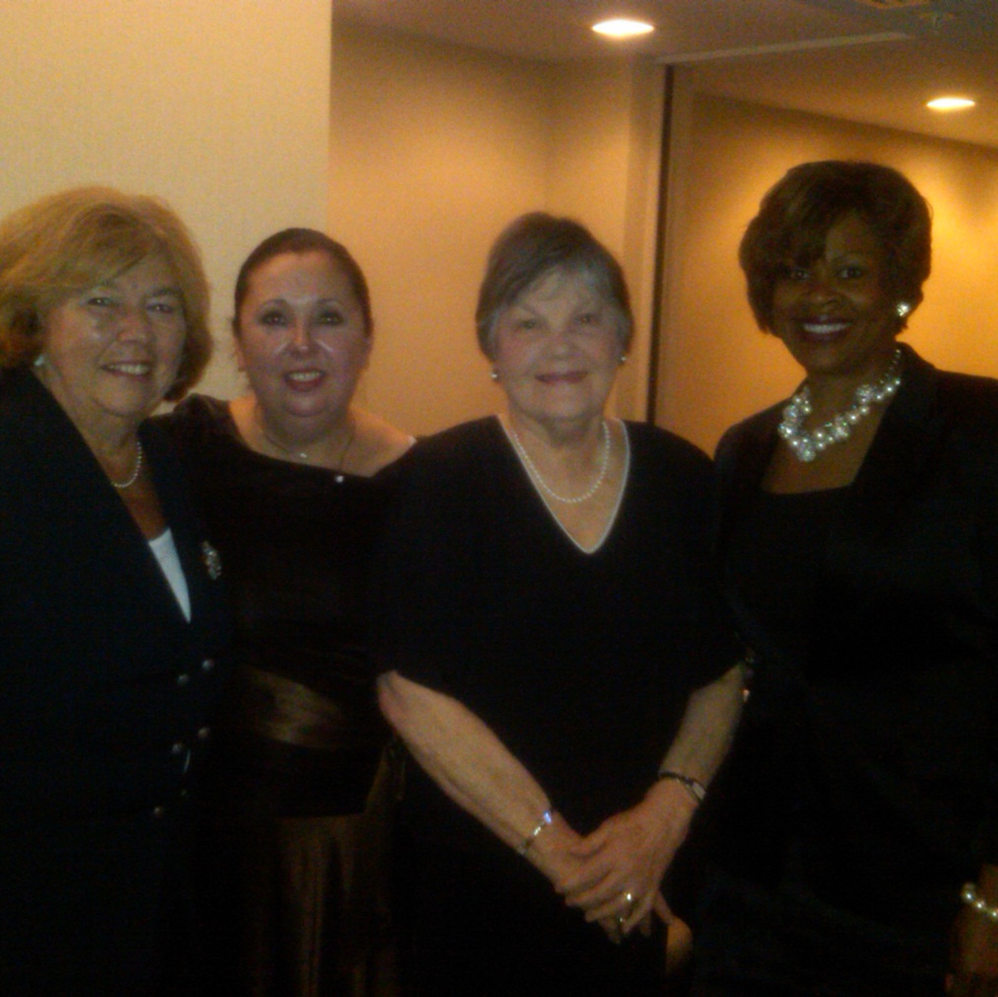
At an AAN meeting - From Left to Right: Dorothy Jones, Margaret Newman (center)
and former students and Newman Scholars Dr. Jacqueline Somerville Dr. Angeline Peters-Lewis

